National Demographic Profiles:

Japan and Bangladesh

Avien Siegfried

Professor Meyer

Population

April 28, 2016

Chapters 1 and 2: Population Growth

**Bangladesh**

Bangladesh’s population growth since its separation from Pakistan in 1971 has been incredibly fast. In 1970 the population averaged 66 million and by 1990 had almost doubled to 105 million (Bangladesh Population.) Today Bangladesh’s population count is 162 million (Bangladesh Population.) Their rate of growth spiked to 3.38% in 1967 before steadily dropping to 1.63% in 1973, more than likely because of the war known as “Bangladesh’s Liberation War” two years earlier (Bangladesh Population, History of Bangladesh.) Bangladesh’s current growth rate is 1.19% (Bangladesh Population.) Doubling time for Bangladesh is estimated to be 20 years as of 2008 (Streatfield,) which is consistent with the population numbers between 1970 and 1990, but recent advances in women’s health services and education might be challenging that number in the future as we will see in Chapter 8 of this paper. The crude death rate is 5.59 deaths per 1000 people while the crude birth rate is 20.83 births per 1000 people (Bangladesh.) The net migration rate in Bangladesh is -2.85 migrants per 1000 of the population (Bangladesh-Net Migration...)

**Japan**

During the mid-1950s Japan experienced a period of economic and political growth. The country rose from an era of depression and economic hardship after their surrender in World War II and became a world leader in terms of technological advancements and manufacturing. Japan’s population went from 82 million in 1950 to 103 million in 1970 thanks to their prosperous economic gains (Japan Population.) In 1955 the population growth rate was 1.09% and reached its highest rate at 1.4% in 1972 (Japan Population.) While Japan has become more and more developed, their growth rate has surprisingly been dropping steadily every year. As of 2016 Japan’s current growth rate is -0.2% meaning that their population is imploding (Japan Population.) Doubling time for Japan can’t be calculated thanks to its negative growth rate. The crude death rate in Japan is currently 9.64 deaths per 1000 people and their crude birth rate is 7.79 births per 1000 people (Japan.) Migration rates for Japan are currently at 0.55 migrants per 1000 of the population (Japan-Net Migration…)

|  |  |  |
| --- | --- | --- |
| **2016 Comparison of Population Growth** | | |
| Country | **Bangladesh** | **Japan** |
| Current Population | 162 million | 126 million |
| Current Growth Rate | 1.19% | -0.2% |
| Est. Doubling Time | 20 years (as of 2008) | - |
| Crude Death Rate | 5.59 deaths per 1000 people | 9.64 deaths per 1000 people |
| Crude Birth Rate | 20.83 births per 1000 people | 7.79 births per 1000 people |
| Net Migration Rate | -2.85 migrants per 1000 of the population | 0.55 migrants per 1000 people |

Figure 1: 2016 Comparison of Population Growth

Sources: See Reference Page or Above Paragraph

Chapter 3: Political Philosophies

**Bangladesh**

Bangladesh is quite a unique country in terms of their political philosophy. It doesn’t seem like government has much power even though they’re in charge of the country. Bangladesh also allows women to hold high positions in government, yet women are treated poorly in the country. I’m not sure what philosophies Bangladesh follows, but in recent years women’s health organizations have definitely taken a step in trying to control the birth rate so those organizations are definitely following a Neo-Malthusian approach to helping the country grow economically. Bangladesh doesn’t follow the stereotypical rural-urban transitions that other countries do. As a developing country, many areas are urbanized; however there are just as many rural areas.

**Japan**

I feel that Japanese political philosophy today is definitely leaning towards anyone who believes that population size is important for economic and social growth, so probably Cicero in the respect that in order to keep Japan a world power there needs to be more people living and working there. In the above chapter we saw that Japan’s population in imploding. Throughout the rest of the paper, especially in Chapters 8 and 12, I discuss that the Japanese government is incredibly concerned with the country’s future as the work force steadily declines due to the dropping birth rates. As Japan is a country who really doesn’t rely on immigration to boost its population size, Japanese officials and economists fear for the future of their country. In this case Japan will cease to be a major world economy as the country shifts to a predominantly elder-based society.

Originally a country where people lived in rural areas, after World War II a vast majority of Japanese citizens moved to urban areas, sparking economic growth (Japan Population.) This switch to a more urban society definitely helped make Japan the country that it is today.

Chapter 4: Country Data

**Bangladesh**

Currently Bangladesh conducts three forms of census: the Population and Housing Census, the Agricultural Census, and the Economic Census. The “Census” page on the website for the Bangladesh Bureau of Statistics allows access to the Agricultural Census data for 2008 for major cities in the country as well as the results of the 2013 Economic Census. There is even a section for important findings thanks to data collected from the different censuses as well as other surveys. Although the site has some good information, it seems to be a bit outdated as the last website update was in 2013. Compared to other databases online, the website design seems outdated as well. The Demographic Health Surveys website featured Bangladesh on the list of searchable countries but didn’t yield any sort of interesting surveys that I felt could be used.

**Japan**

Japan’s Statistics Bureau site is much cleaner than Bangladesh’s and is updated daily. The information is even easily accessible in English, which is a plus. Japan definitely seems to take many more surveys as their “Statistics” page has more options and each link on the page leads to a page with even more options. Japan holds a Population Census, Economic Census, Establishment and Enterprise Census, and Economic Census for Business Activity. Census information is available on the site as well as a full records of the conferences created to discuss the results of each census. The Demographic Health Surveys website didn’t have Japan on the list, although I’m sure if it had been included I would have found better information than I did for Bangladesh.

Chapter 5: Age and Sex Specific Mortality

|  |  |
| --- | --- |
| **Top 10 Causes of Death** | |
| **Japan** | **Bangladesh** |
| 1. Influenza and Pneumonia | 1. Lung Disease |
| 2. Stroke | 2. Tuberculosis |
| 3. Coronary Heart Disease | 3. Influenza and Pneumonia |
| 4. Lung Cancer | 4. Stroke |
| 5. Stomach Cancer | 5. Coronary Heart Disease |
| 6. Colon-Rectum Cancer | 6. Diabetes Mellitus |
| 7. Other Injuries | 7. Kidney Disease |
| 8. Liver Cancer | 8. Liver Disease |
| 9. Pancreas Cancer | 9. Hypertension |
| 10. Suicide | 10. Low Birth Weight |

Figure 2: Top 10 Causes of Death in Japan and Bangladesh

Source: WorldLifeExpectancy.com

The chart above lists the top 10 causes of death in both Japan and Bangladesh for an unknown year. I believe the site keeps track of the top ten list each year and ranks them accordingly in one generalized list. The highlighted causes of death are shared between both countries. Although number 8 on each side isn’t the exact same, it’s interesting to see that both countries suffer from liver ailments as one of their top causes of death.

Bangladesh’s side of the “Top 10” chart is full of diseases while Japan’s side is mostly cancer. The top killer for each country deals with lung related ailments. It’s surprising that the flu is Japan’s number one killer, as we rarely ever hear of people dying from the flu in a developed country thanks to advanced medicine. Pneumonia is understandable, as many people contract the disease even in the United States and it’s recurrent. Japan’s side is mainly cancers and other degenerative problems like heart disease while Bangladesh’s side is full of diseases. You can definitely see the signs that Bangladesh is becoming developed as stroke and heart disease are in the top five killers. Number ten on both sides is probably the most interesting cause of death. In the developed country the tenth cause of death is suicide while in the developing country low birth rate is the tenth killer. In one country we see people taking their lives even though they have so many opportunities and in another we see infants struggling to even reach the age of one thanks to either malnutrition or poor health of the mother. It’s somewhat sad to see the struggle of one country who can’t even keep infants alive versus a country that one would think has people who are happy with their lives, but in reality are not and resort to killing themselves.

While I couldn’t find complete age and sex specific death ratios for Bangladesh, I was able to find out that at almost every age women are at higher risk for dying in the country than men (GDP Profile…) This definitely is another red flag that points to the way women are treated in society. High birth rates even with contraceptive use and increased risk of death at all ages shows that women are not being treated very highly in society. The opposite is true in Japan. Data from the National Institute of Population and Social Security Research shows that sex specific death rates at every age are almost equal for both men and women. This makes sense as women and men in Japan are treated equally and have access to the same opportunities.

Chapter 6: Fertility Levels

**Bangladesh**

Fertility in Bangladesh in 2015 was at 2.37 births per woman (Bangladesh Population.) They are definitely at and above replacement level. Fertility in Bangladesh seems most likely to be linked to the status of women in Bangladeshi society. Married women in Bangladesh do use birth control, 62% using any form and 54% using modern methods (2015), but lack of education or improper use of contraceptives may be blocking the effectiveness of birth control methods and family planning. As Bangladesh is a patriarchal society it is also possible that pressures for a male son or multiple sons may affect how often a woman uses contraceptives as well. After all, the World Population Data sheet doesn’t specify how often birth control is used.

**Japan**

Japan’s fertility rate is a bit harder to understand than Bangladesh’s. As of 2015 Japan’s fertility rate is 1.41 births per woman (Japan Population.) Women in Japanese society are treated much like women in the United States are and are pretty much equal to the males in society in terms of opportunities and standard of living. 54% of married women in Japan use some form of birth control and 44% use a modern method (2015), which is definitely a contributing factor to their low birth rate, fertility rate, and their negative growth rate. Just looking at the numbers it seems odd that Japan has a lower percentage of women using birth control but has less children being born than Bangladesh. Taking into account the fact that Bangladesh’s population is larger, it makes sense that less children would be born in Japan. However the fact that Japan is facing negative population growth definitely shows that there is something wrong.

Japan’s low fertility seems to stem more from a mindset that marriage can be delayed. A survey done by the Japan Times showed that almost 40% of single Japanese citizens who participated had no interest in finding a partner and getting married (JIJI.) With such apathetic views on marriage and romance it’s no wonder that in 2014 the Japanese government focused heavily on matchmaking services and poured $29.3 million into the economy in order to stimulate population growth (Ghosh.) Delaying marriage to finish school and get a stable job is a good idea, and is something that singles in the United States have also started leaning towards. The only problem is when too many people start to delay marriage and no one is starting families and replacing themselves.

Chapter 8: Age and Sex Population Pyramids

**Bangladesh in 2010**

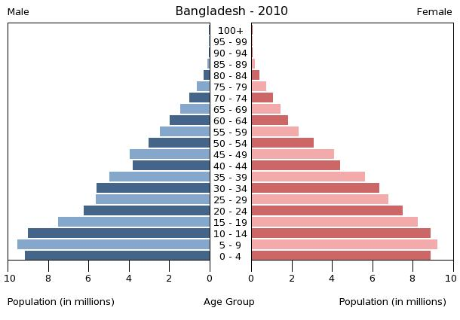

Figure 3: Bangladesh Population Pyramid 2010

Source: Census.gov

Bangladesh’s population pyramid for the year 2010 clearly shows that the country was experiencing a youth bulge. Age groups 0-24 have the highest amount of people in them, with age group 10-14 having the largest number. The amount of infants and toddlers making up Bangladesh’s population during the year is also very alarming: there are over 8 million of them. Although Bangladesh is considered a developing country, it is still stricken with an incredible amount of poverty and having so many children poses a problem when it comes to allocation of resources and standard of living for those children. The ratio of children to adults is definitely skewed in this country, with the amount of children greatly overshadowing the adults. A main reason for the alarming amount of children is the general treatment of women in Bangladeshi society. By law women are protected against child marriage, but they are still subject to arranged marriage and the traditional dowry system (Forced Marriage in Bangladesh.) Although illegal, women are typically married before the legal age of 18 (Forced Marriage in Bangladesh.) The fact that arranged marriages still happen in Bangladesh is a huge indicator that men are in charge in society and women take on the role of their property. As discussed in class, this lesser role of women in a society leads to more kids and a lessened standard of living for both mother and child.

On the opposite end of the population pyramid, ages 80-100 were almost nonexistent compared to the younger age brackets. According to the Central Intelligence Agency (CIA,) the average life expectancy during the year 2015 was averaged between men and women at 70.94 years old. Going back a few years one can definitely assume that life expectancy was a little lower; probably around 67-69 years old for 2010. Starting at age 45 was when the population pyramid started to show a steady decline. For each following age bracket the numbers got lower and lower. This definitely backs up the data that the average life expectancy was in the late 60’s and early 70’s. In terms of the age-sex ratio, it looks like there were just a tad more women in each age group than men; however the difference was definitely not drastic. The first noticeable age bracket where there were more women was ages 30-34 but for all the others the ratio of males to females was about even.

While the average life expectancy was around 70 years old, the median age in Bangladesh for 2010 was 23.9 years old (Bangladesh: Average Age of…) This is definitely not surprising as the overall life expectancy of 70 years old is pretty low compared to that of a developed country so of course the median age is going to be young. One number that definitely wasn’t low for Bangladesh was their age dependency ratio. According to IndexMundi for 2010 the ratio was 56.9. Looking at the population pyramid it’s not hard to see why the number was so large, especially with the huge chunk of the population that’s younger than 15. Although people might want to take care of the elderly in Bangladeshi society, it seems that the younger portion of the population is sapping all the resources.

**Bangladesh in 2016**

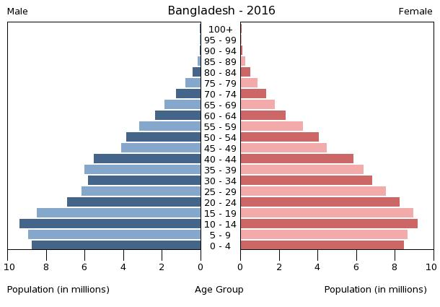

Figure 4: Bangladesh Population Pyramid 2016

Source: Census.gov

Fast forward six years later and it looks like Bangladesh has lowered the amount of infants in their society and their population pyramid for adults in the middle has filled out somewhat. The age group with the most drastic increase is age group 40-44. Every age above 10 years old has gained a slightly noticeable amount of people. Looking at the two years side by side, ages 0-4 have definitely decreased within the past six years. This is definitely a good thing for Bangladesh since infants and toddlers were sapping up most of the resources back in 2010 and driving up the dependency ratio. As discussed in the above section, women in Bangladesh don’t really have much say in their society which is more than likely the main reason why there are so many children being born each year. In recent years, however, there have been movements to empower women in Bangladesh and educate them on the use of birth control and other family planning methods. Groups like the Bangladesh Women’s Health Coalition and Genoshasthaya Kendra have been working since the 1980’s to help bring down Bangladesh’s fertility by providing family planning services to the women of Bangladesh and their efforts are slowly but surely showing results (Rizvi.)

While the amount of children being born in Bangladesh has definitely decreased over the past six years, the amount of people living over the age of 70 has increased. The population pyramid noticeably shows more people in the 85-90 age bracket which hints that the standard of living is starting to get better as people are living longer. Median age in Bangladesh also increased to 24.3 years as of 2014, so I can only assume that for the year 2016 the number might be around 24.5 or so (Bangladesh Demographics…) The increase in median age definitely means that Bangladesh is becoming a more developed country. In addition to the increase in median age, there was also a drop in the age dependency ratio. While 2010’s was 56.9, 2014’s was 53.7 (Age Dependency…) For 2016 the number probably dropped a bit.

**Japan in 2010**

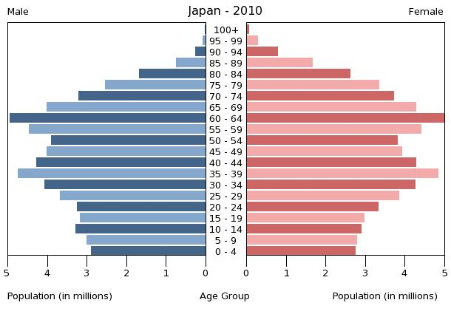

Figure 5: Japan Population Pyramid 2010

Source: Census.gov

Japan’s 2010 population pyramid looks nothing like a pyramid and more like a slowly forming rectangle. The amount of people in the age bracket 60-64 is particularly amazing to me as they were the largest group on the whole pyramid. In 2010 almost 3 million babies were born and the working age population looked pretty healthy to me if I excluded the elderly. Women and men are treated equally in Japanese society so it makes sense that each age bracket has around the same amount of each sex. Japan is a developed country so of course their adult to child ratio is going to be well balanced along with their sex ratio at each age. When it comes to getting older, however, women definitely seem to live longer in Japan. Age bracket 60-64 on the women’s side reached all the way to the edge of the chart, but the men weren’t that far behind. A noticeable difference in the age to sex ratio can be seen starting at age 70 and that difference becomes more pronounced at every age bracket: women do live longer.

According to the Pew Research Center, median age in Japan for 2010 was 45 years old.

That’s much better than Bangladesh during both 2010 and 2016. Seeing as Japan is a developed country with a very good life expectancy, one would expect that their dependency ratio would be smaller than Bangladesh. Shockingly that isn’t true. The dependency ratio in 2010 was 56.9 according to IndexMundi. That is the exact same as Bangladesh in 2010. The reason for this high dependency ratio is the opposite from Bangladesh. While Bangladesh’s work force supports a small amount of elderly and a large amount of children, Japan’s supports a large amount of elderly and a small amount of children.

**Japan in 2016**

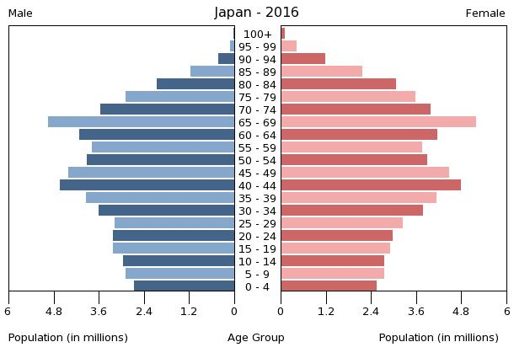

Figure 6: Japan Population Pyramid 2016

Source: Census.gov

While the differences between population pyramids for Bangladesh were not super noticeable, the changes for Japan are. Even side by side the changes are incredibly clear. Japan’s 2016 pyramid is even more of a rectangle than the one for 2010. Census.gov even had to change the numbering on the bottom of the 2016 pyramid to further emphasize the shrinkage in population size. The number of people from ages 0-84 all shrank. The only gains that were made are from ages 85 and up. What’s even more shocking is how dramatically births fell. One would think a society that has working-age age groups shrinking and the amount of elderly rising would want to have more children to keep their society running, but that’s definitely not the case in Japan. Chapter 6 of this paper went over how Japanese singles are not interested in marriage and the amount of births per year is dropping drastically because of that.

The median age in Japan for 2016 is 46.9 according to Worldometers. That’s very close to being a two year increase in just six years. If people are going to live longer in Japan how do they expect to keep cities and businesses running? If a majority of the society is old and cannot work who will be in charge of the country? Japan is facing a very unique dilemma of rapid implosion that needs to fixed as soon as possible. Even if Japanese citizens decided to start having many children as soon as today, those children will probably not reach working age in time to support the incredible amount of elderly in the country. WorldBank’s data shows that Japan’s 2016 dependency ratio is 63. That’s a 6.1 increase from 2010. As the population keeps aging this number is just going to get bigger. Bangladesh’s dependency went down in 2016, but Japan’s just keeps going up.

Chapter 12: Population Trends and Summary

If the comparison between Bangladesh and Japan were a contest, Bangladesh would be winning. While Bangladesh does have a very large population, the data from the population pyramids (Figures 3 and 4) definitely shows improvement in their overall society. As a developing nation, each year Bangladesh’s life expectancy and median age continue to increase while dependency ratio drops. The only issue Bangladesh really needs to address is how women are seen in society. I can imagine that if women were equal to men in Bangladesh the amount of children being born would definitely drop down closer to 2 children per woman and the society would be able to use their resources to better their economy instead of taking care of millions of infants. Bangladesh’s population seems to be shifting into the ideal pyramid shape, although somewhat slowly, but the country is coping very well with the changes. I really have hope for a better future for Bangladesh and the women who live there.

I wish I could have the same hope for Japan. As technologically and economically advanced as Japan is, unfortunately the country may not be surviving in the near future. Each year the population pyramid gets more rectangular as more and more people reach retirement age and less children are born. Japan’s fertility is not at replacement level at all, and with a growth rate in the negatives there really needs to be a proactive change in the society. It doesn’t matter that Japan’s life expectancy is one of the highest in the world if no one is going to be around to take care of the elderly in the future. The work force is slowly shrinking and the dependency ratio goes up every year. All efforts to raise the amount of marriages and births have been pretty much futile. It really doesn’t seem like average Japanese citizens understand what will happen to their society and their country if this trend continues. The only people who seem to care about Japan’s implosion are those with a strong understanding of its dangers such as economists and government officials.

**References**

“Age Dependency Ratio.” WorldBank. N.p., n.d. Web. 12 Apr. 2016.

“Age Dependency Ratio – Old in Bangladesh.” *Trading Economics*. N.p., n.d. Web. 12 Apr. 2016

"Age - Specific Mortality Rates by Sex." *National Institute of Population and Social Security Research*. N.p., n.d. Web. 11 Apr. 2016

“Aging in the U.S. and Other Countries, 2010 to 2050.” *Pew Research Center*. N.p., 30 Jan. 2014. Web. 12 Apr. 2016.

"Bangladesh." *Geoba.se*. N.p., n.d. Web. 27 Apr. 2016.

“Bangladesh – Age Dependency Ratio.” *IndexMundi*. N.p., n.d. Web. 12 Apr. 2016.

“Bangladesh: Average Age of the Population from 1950 to 2020.” *Statista.* N.p., n.d. Web. 12 Apr. 2016.

“Bangladesh Demographics Profile 2014.” *IndexMundi.* N.p., n.d. Web. 12 Apr. 2016.

"Bangladesh - Net Migration Rate." *Knoema*. N.p., n.d. Web. 27 Apr. 2016.

"Bangladesh Population." *Worldometers*. N.p., n.d. Web. 27 Apr. 2016.

"Census." *Bangladesh Bureau of Statistics*. N.p., n.d. Web. 27 Apr. 2016.

“Forced Marriage in Bangladesh.” *Dhaka, Bangladesh – Embassy of the United States.* N.p., n.d. Web. 27 Apr. 2016.

"GDP Profile: Bangladesh." SpringerReference (n.d.): n. pag. *HealthData.org*. Web. 11 Apr. 2016.

Ghosh, Palash. "Japan Encourages Young People To Date And Mate To Reverse Birth Rate Plunge, But It May Be Too Late." *International Business Times*. N.p., 21 Mar. 2014. Web. 10 Apr. 2016.

"History of Bangladesh." *Visit Bangladesh*. N.p., n.d. Web. 27 Apr. 2016.

“International Programs.” *Census.gov.* Np., n.d. Web. 12 Apr. 2016.

"Japan." *Geoba.se*. N.p., n.d. Web. 27 Apr. 2016.

“Japan – Age Dependency Ratio.” IndexMundi. N.p., n.d. Web. 12 Apr. 2016.

"Japan - Net Migration Rate." *Knoema*. N.p., n.d. Web. 27 Apr. 2016.

“Japan Population.” *Worldometers*. N.p., n.d. Web. 12 Apr. 2016.

JIJI. "Nearly 40% of Single Japanese Not Interested in Romance: Survey." *Japan Times*. N.p., 22 June 2015. Web.

“Life Expectancy at Birth.” *Central Intelligence Agency.* Central Intelligence Agency, n.d. Web. 12 Apr. 2016

"Politics and Political Campaigns in Japan." PBS. *PBS*, n.d. Web. 27 Apr. 2016.

"Postwar Japan, 1952-1989." *About Japan: A Teacher's Resource*. N.p., n.d. Web. 27 Apr. 2016.

Rizvi, Najima. “Spectacular Achievement.” *D+C.* N.o., 19 Mar. 2014. Web. 12 Apr. 2016.

"Statistics." *Statistics Japan*. N.p., n.d. Web. 27 Apr. 2016.

Streatfield, Peter Kim, and Zunaid Ahsan Karar. "Population Challenges for Bangladesh in the Coming Decades." *Journal of Health, Population, and Nutrition*. International Centre for Diarrhoeal Disease Research, Bangladesh, n.d. Web. 27 Apr. 2016.

"World Life Expectancy." *World Life Expectancy*. N.p., n.d. Web. 18 Mar. 2016.

"2015 World Population Data Sheet." 2015 World Population Data Sheet (n.d.): n. pag. Population Reference Bureau. Web. 12 Apr. 2016.